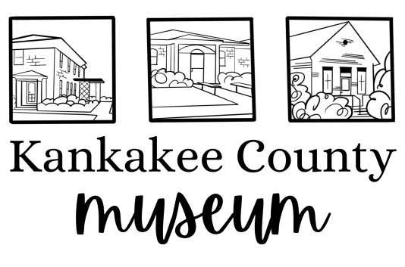

Collections Intern Description
Collections Interns are responsible for the care and preservation of the museum’s collections. Interns will work under the direction of the Curator and Executive Director as needed. Collections Interns will work specifically at the Kankakee County Museum from the back office and the collection storage rooms.
Persons in this role will be responsible for completing the following tasks:
1. Aid in properly accessioning and cataloging physical artifacts within the museum’s collection.
2. Locate objects within the storage space that need to be accessioned or transferred over to the new CatologIt collection system.
3. Aid in creating specific subject “hubs” in the CatologIt system.
4. Assist the Curator with developing and evolving museum exhibitions.
5. Care for and conserve Museum artifacts.
6. Be available to the general public to answer questions about Museum Collections policies.
7. Work with the Curator and Executive Director on organizing the collection materials.
8. Understand, digitize and maintain physical records of all Deed of Gift files.
Persons applying for this role should have the following background/skills:
Excellent written and verbal communication skills.
- Project management and organizational skills.
- Ability to multitask.
- Knowledge of working with museum databases, IT issues, Microsoft programs, Photoshop, and other design platforms.
- Resourcefulness, quick problem-solving abilities, and strong collaboration skills.
- Some college or applicable experience recommended but not required
Interested applicants can please send resumes to Veronica Featherston at veronicafeatherston.k3museum@gmail.com

