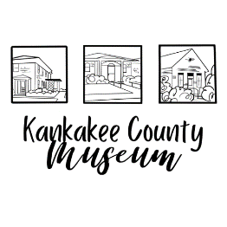

“Home of the Kankakee Historical Society”
801 South 8th Avenue, Kankakee, Illinois 60901
(815) 932-5279 Fax (815)932-5204
www.kankakeecountymuseum.com

The 34th Annual Rhubarb Festival is coming up fast.

This year our event will be held on
Sunday, May 19, 2024 from 10 a.m. to 4 p.m.

The Rhubarb Festival is always well attended with activities for the entire family. Guests may visit the Dr. A.L. Small Home, the Taylor Schoolhouse, and the Museum. Enjoy a slice of pie on the Museum Campus, buy a whole pie, or spend time browsing the many local organizations and vendor tents set up on the Museum grounds and inside the Civic Auditorium.

We are inviting vendors and community organizations to participate by having your own spot on the Rhubarb Festival grounds. You may sell merchandise, promote memberships, hand out information about your group available to increase public knowledge about your community activities, and how others can get involved. You may NOT sell items that compete with the KCHS fundraising (ex: jams or pies) unless prior authorization is permitted.

Each organization must supply their own tent, tables, chairs and signage. Set up starts at 7 a.m. and booth location will be assigned.

Food vendors must comply with Kankakee County EPA/Health Department licensing.

Accepted forms of payment include; all forms of credit cards, checks, cash, and PayPal.
To register;
- Call 815-932-5279 to pay by phone
- Fax information to 815-932-5204
- Visit us on the web at www.kankakeecountymuseum.com
- Mail information to 801 S 8th Avenue Kankakee IL 60901
- Stop by the Museum Thursday – Saturday 9am to 5pm

For more information please call the Kankakee County Museum
815-932-5279

